Project Design Phase-II
Data Flow Diagram & User Stories

Date | 04 February 2026
Team ID | LTVIP2026TMIDS66236
Project Name | Explore With Ai: Custom Itineraries For Your Next Journey
Maximum Marks | 4 Marks

Data Flow Diagrams:
A Data Flow Diagram (DFD) is a traditional visual representation of the information flows within a system. A neat and clear DFD can depict the right amount of the system requirement graphically. It shows how data enters and leaves the system, what changes the information, and where data is stored.

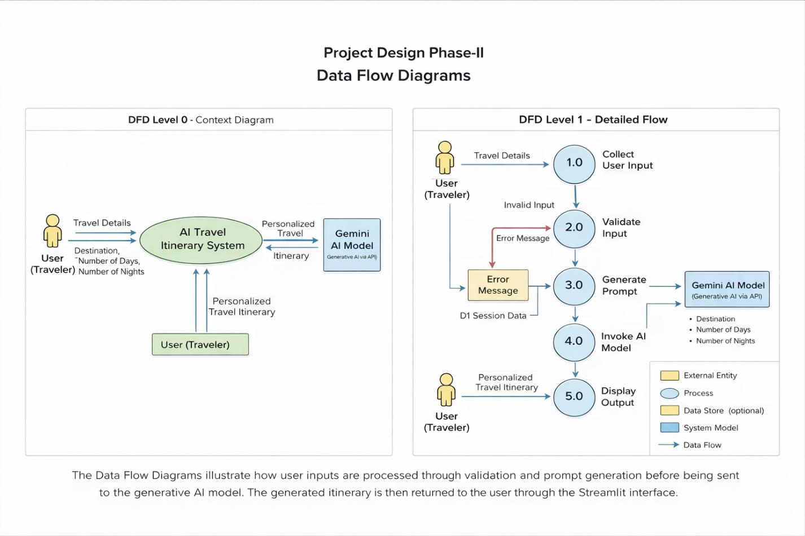

User Stories
Use the below template to list all the user stories for the product.
User Type | Functional Requirement (Epic) | User Story Number | User Story / Task | Acceptance criteria | Priority | Release
Customer (Web user) | Travel Itinerary Generation | USN-1 | As a user, I can enter my destination, number of days, and number of nights to generate a personalized travel itinerary. | The system generates a structured travel itinerary based on the entered details. | High | Sprint-1
Customer (Web user) | Input Validation | USN-2 | As a user, I want the system to validate my input details before generating the itinerary. | If inputs are invalid, the system displays an appropriate error message. | High | Sprint-1
Customer (Web user) | AI Integration | USN-3 | As a user, I want the system to use generative AI to create a detailed travel itinerary automatically. | The AI generates a day-wise itinerary including activities and travel tips. | High | Sprint-2
Customer (Web user) | Output Display | USN-4 | As a user, I want to view the generated itinerary clearly on the web interface. | The itinerary is displayed in a readable format in the application. | Medium | Sprint-2
Customer (Web user) | Error Handling | USN-5 | As a user, I want the system to handle API or runtime errors gracefully. | If an error occurs, the system displays a user-friendly error message without crashing. | Medium | Sprint-3

